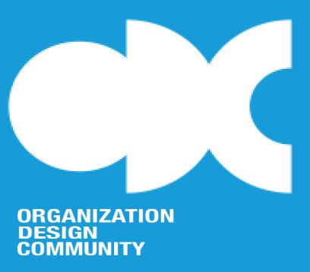

Organization Design Community
Chairman’s Annual Report 2021

Because my final term as ODC Chairman expires this year, this will be my last Chairman’s Annual Report. I’d like to take this opportunity to briefly review ODC’s major accomplishments over its ten-year history. This will provide context for my description of the progress ODC made in 2020-21.

ODC was established in 2010 as an international community of scholars and business professionals dedicated to advancing the theory and practice of organization design. ODC’s vision is to be the preeminent community in the area of organization design, with the overall goal of bridging the gap between theory and practice. Currently, ODC has more than 200 members as well as many friends and supporters on LinkedIn and other sites.

ODC has made many notable accomplishments over the past ten years, including:

- Journal of Organization Design

ODC created JOD in 2011 as an open access journal focused exclusively on the subject of organization design. In the beginning, JOD was self-published by ODC, and the first set of articles was published in 2012. In 2016, SpringerOpen took over publication of the journal while ODC continued to own and operate it. In 2021, Springer Nature began to publish JOD as a hybrid journal – available both by subscription and open access. JOD has steadily grown and improved, and it is now included in Scopus, a prominent abstract and database indexing service. The editorial team and review board are populated with some of the best-known organization design experts in the world.

- Annual Conference

Every year ODC holds a conference. Two ODC members organize the conference by announcing a timely and important theme, preparing the program, and inviting notable academic and practitioner speakers and discussants. The Annual Conference is always highly anticipated and valuable. Due to the coronavirus pandemic, last year’s conference was virtual.

- Webinar Series

ODC organized a Webinar Series to provide a means for ODC members to present their work to other ODC members. The Webinar Series is very popular, with regularly scheduled webinars presented on both research and practice topics. Webinars are well attended, and all webinars are archived in ODC’s growing knowledge repository.

- Podcast Series

In response to the coronavirus pandemic, ODC developed a podcast series called Remote at Work and made it publicly available. Many organizations closed their offices during the pandemic and required employees to work from home. The podcast series presented research and guidance on how remote work can and should be performed. Subsequently, the series changed its focus to organizational resilience, a post-pandemic topic of widespread interest.

- ODC-C

Given the deep knowledge and expertise in the community, ODC decided several years ago to enter the accreditation business. It formed ODC-C, a commercial company that could receive revenues for ODC’s accreditation services. ODC uses a well-developed set of criteria to evaluate organization design courses offered by various course providers. In addition, ODC formed an alliance with the Organization Design Forum and the European Organisation Design Forum to certify organization design professionals. The Certified Organization Design Professional program has grown steadily over the years.

Against this historical backdrop, ODC made significant progress during 2020-21:

- ODC increased its social media presence and redesigned its website. The goal is to continue to increase ODC’s visibility and respectability in the world of organization design.
- We expanded the Webinar Series both in scope and volume. The Webinar Series is becoming increasingly valuable to ODC members in terms of increasing their knowledge of design-related topics and providing opportunities to present their own work.
- In January 2021, Brian Wu (University of Michigan) and Oliver Baumann (University of Southern Denmark) took over as Chief Editors of the Journal of Organization Design. They will serve a three-year term. Furthermore, JOD was accepted into the Emerging Social Sciences Index, a major step in gaining acceptance into the Web of Science. JOD is well positioned to become the leading academic journal on the subject of organization design.
- In collaboration with UNHCR (United Nations Refugee Agency), ODC launched the Organizing for Good campaign, an ambitious effort to explore how organizations can be designed/redesigned to help pursue the UN’s 17 Sustainable Development Goals. Organizing for Good was created to celebrate ODC’s tenth anniversary and to contribute to the UN’s efforts to improve global society.
- Accenture, the global professional services firm, became ODC’s first Corporate Member in 2021. Given its intent to have the world’s best consulting practice in organization design, Accenture is a logical and valuable choice to be ODC’s first Corporate Member.

It has been an honor and pleasure for me to have served as ODC’s Chairman for its first decade. ODC’s members are impressive, and the leadership of ODC, JOD, and ODC-C continues to be strong. I look forward to many more years of ODC growth and success, and I hope your membership in the community has been and will be worthwhile.

